England Athletics Under 17 and Under 15 Championships
Four Newquay and Par athletes travelled to Bedford this bank holiday weekend to compete in the national age group championships. The great performances by all four athletes made the long trip worth it.

On Saturday Lewis Cotterill competed in the U17 1500m Steeplechase final. With 14 top athletes in the country involved this was going to be a big step up in class, but one Lewis relished. From the start he was barged and pushed and had to jump over the hurdles in a pack, something he is not used to on the local tracks. Lewis went to the front to combat this, but paid mid-race as the other athletes all went past him. Despite this Lewis fought back and went past a number of athletes to finish a highly credible 9th. He came off the track buzzing and will be much the better athlete for this experience, which will be invaluable for future races at this level.

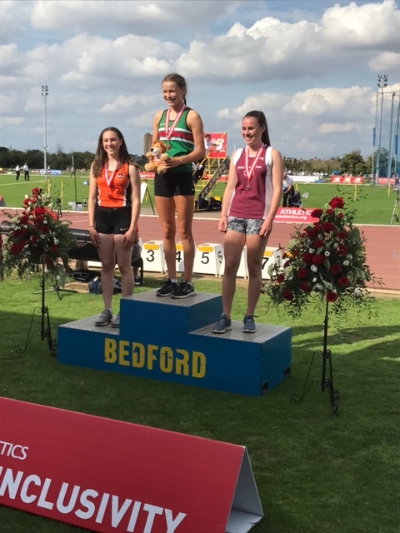
In the field Lucy Allen was competing in the U15 Pole Vault. The 10 strong field included the top 4 athletes in the UK so was set to be a top competition and the supporters were not let down. With so many athletes Lucy had to wait over an hour to start the competition and caught her competitors out by coming in at 3.16, one jump later than her three main rivals. Lucy gained the initiative by completing a perfect vault. Jumping first of the big guns, and vaulting smoothly at 3.26 and 3.36 the tactics paid off as two of her rivals fell by the way side. After one failure at 3.46, Lucy came back strong and cleared a new pb, which was also cleared by the winner Sophie Ashurst who cleared 3.56. Lucy was so close to clearing 3.56 and can look forward to doing this in the near future. The silver medal means Lucy has a full set (gold, silver and bronze) of national medals this year.

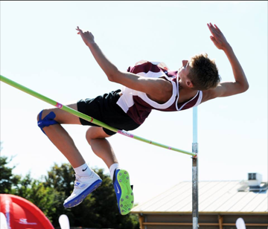
On Sunday Sam Brereton kicked off the field events in the U15 high jump. Sam was against all the regional winners from the week before. However, being the number one ranked athlete there was a high level of expectation. Sam was not feeling great and after an indifferent warm up session this looked to be a tough competition for Sam. Following some wise words from coach and Jedi Master Clive (Marsh) Sam improved as the competition went on. Sam came in at 1.76, which saw the end for over half of the 14 field. First time clearances at 1.80 and 1.83 left three athletes. Further first time clearances at 1.86 and 1.89 and the gold was Sam’s. Sam then jumped 1.93 before clearing 1.97, a championship best performance (CBP). A nice touch was the current CBP holder, Dominic Ogbechie, congratulating Sam on the record. 2.01 proved to be one step too many on the day, but will be the target for another day. Sam has now won all three of the national championships this year.

Sunday afternoon saw Elowen Penfold in action in the 1500m Steeplechase final. Having missed the winter due to an achilles tendon injury and not competing at the English Schools championship Elowen had come into the race under the radar. However, her competitors soon were aware of Elowen as she led from the gun and stretched the field as the race progressed. With a lap to go Elowen had built up quite a lead so we were starting to believe she could win and despite her closest competitors making a big push in the final lap to catch her, Elowen was able to kick on and win in a very respectable 5m 17.11. This was unexpected but much deserved and capped a great weekend for the local athletes.

